Cost of Health Services Regulation
Working Paper Series

Medicare Payment Rules for Health Professionals

Health Professionals Regulation
Working Paper No. P-1

Prepared by

Christopher J. Conover
with
Emily P. Zeitler

Center for Health Policy

Duke University


Under contract to the

Agency for Healthcare Research and Quality

With funding from ASPE/DALTCP

The authors thank Will Acuff, Erica Fritz, Anne Farland, Jessica Laux, John Siracusa and Catherine Wu for excellent research assistance with this paper.

Section I. Introduction

Background

Rationale
Medicare payment rules for health professionals--including restrictions on balance billing and restrictions on private contracting--have evolved in conjunction with changes in the Medicare fee schedule. Restrictions on balance billing were motivated by concerns over the rising burden of out-of-pocket costs on Medicare beneficiaries and the prospect of a two-tiered system in which those able to afford to pay fees in excess of Medicare allowable charges would obtain better access to high-quality care. Likewise, restrictions on private contracting reduce the possibility that providers will evade restrictive Medicare payment rules by simply making private arrangements with their Medicare patients. Both of these regulations permit Medicare regulation of provider fees to be more restrictive than it would otherwise be.

Statutory Authority
Balance Billing Restrictions.
Medicare assignment rules have existed since the inception of Medicare.
1984: The Deficit Reduction Act of 1984 (DEFRA 1984) established the Medicare Physician Participation Program to provide physician incentives to accept assignment on all claims (DHHS 1993).
1987: Beginning in November 1987, the incentive to accept assignment was increased as HCFA began to allow reasonable fees to rise more quickly for those willing to accept all patients on assignment (Paringer and Fon 1988).
1989: As part of the initiative to move towards a physician fee schedule, the Omnibus Budget Reconciliation Act of 1989 (OBRA 1989) was enacted to cap the amount that nonparticipating physicians may balance bill.
1991: The cap created by OBRA 1989 (the “limiting charge”) was initially implemented in January 1991.
1993: After several subsequent increments, the cap was finally tightened in 1993 to 115 percent of the allowed payment.

Private Contracting Restrictions.
1997: Section 4507 of the Balanced Budget Act of 1997 (BBA 1997) amends section
1802 of the Social Security Act (42 U.S.C. section 1395a). Though BBA 1997 ostensibly seeks to expand the right to privately contract by opting out of Medicare and bypassing the program’s rules entirely, its draconian terms have instead created a major barrier to private contracting (Greeson & Gunas 2000; Hoff 2002).

Key Elements
Medicare is the only insurance option for those age sixty-five or older, since except for supplemental policies designed to complement Medicare, no other private insurance plan covers Medicare-qualified benefits (Greeson & Gunas 2000). This monopsony feature provides Medicare with a degree of leverage not typical of private markets.
Balance Billing Restrictions. When Medicare began, providers had complete freedom of choice regarding Medicare assignment. Assignment is an agreement by the provider to accept Medicare’s allowed amount as payment in full; those accepting assignment receive 80 percent of the allowed amount and bills the beneficiary for the remaining 20 percent. When assignment is not accepted, the beneficiary is responsible for paying the physician and Medicare pays the beneficiary 80 percent of the Medicare-approved amount (DHHS 1993). Physicians not accepting assignment had the freedom to balance bill the patient for the full difference between their fees and Medicare payment; the sole exception was that balance billing was prohibited for Medicare eligibles who were also enrolled in Medicaid (Colby et al., 1995). Until 1983, the choice to balance bill was on a claim-by-claim basis; under DEFRA 1984, physicians were given incentives to participate or not participate; these inducements included higher payment rates than for nonparticipants, being included in a directory of participating physicians and more timely processing of claims. Participating physicians were required to accept Medicare-allowed charges as payments in full for all Medicare patients whereas non-participating physicians could still balance bill on a claim-to-claim basis (Colby et al., 1995).
The first cap on balance billing (OBRA 1989) was implemented in 1991-- eventually was finally tightened in 1993 to 15 percent of the allowed payment for non-participating physicians; since payment rates for these physicians are limited to 95 percent of the Medicare fee schedule amount, the cap effectively limits physicians to receiving no more than 9.25 percent above the Medicare allowed fee schedule amount. Thus, while not moving fully in the direction of mandatory assignment, these changes provided a much stronger impetus to become a participating physician, especially since nonparticipating physicians are liable for collecting from the patient the full amount of their fee.
Apart from federal restrictions, Massachusetts, Rhode Island and Pennsylvania forbid balance billing of all Medicare beneficiaries; Connecticut and Vermont prohibit balance billing for beneficiaries with low income and New York caps balance bills at levels lower than Medicare’s (Colby et al., 1995).
Private Contracting Restrictions. Section 4507 of BBA 97 authorizes providers to privately contract with patients but only if the provider agrees not to accept any Medicare payments for any Medicare beneficiary for at least two years. Patients continue to have the freedom to still privately contract for services excluded from Medicare (e.g., cosmetic surgery).

Scope
The balance billing restrictions apply to all physicians wishing to participate in Medicare. The private contracting restrictions only apply to Medicare covered services, meaning they apparently only apply to Medicare beneficiaries not enrolled in managed care. That is, if a Medicare HMO member seeks out-of-network services not covered by the HMO, by definition that service is not covered by Medicare and hence the patient is permitted to arrange to obtain such care from a physician without that physician having to opt out of the program for 2 years (Hoff 2002). Although CMS takes the position that section 4507 applies only to Part B Medicare beneficiaries, the actual language of the amendment defines Medicare beneficiaries as individuals eligible for either Part A or Part B. Likewise, even though CMS states that section 4307 is not applicable to beneficiaries using Medical Savings Account, but even if this were true, physicians would be strongly discouraged from providing care and being paid from a patient’s MSA since if the patient were not truthful about the source of funds, it could mean the physician could be liable for having violated the private contracting provision. Most physicians will not take that risk (Hoff 2002).

Enforcement
Medicare carriers monitor a sample of claims for all physicians’ unassigned claims for the first and second half of each year. If the cumulative amount of potential excess charges reaches $300, a notice is sent to the physician identifying all such charges. If potential violations are confirmed, the physician is intensively monitored and may be subject to civil monetary penalties or exclusion proceedings (OIG 1993).
Under section 4507, if a physician “knowingly and willfully” submits a claim during the two-year opt-out period, Medicare may make no payment to that physician for any service provided to any Medicare patient during that period (Hoff 2002).

Research Questions
This working paper covers two major topic areas framed within three research questions, all of which are related to the impact of Medicare payment rules for health professionals in the U.S. Our primary goal was to identify, review, and evaluate the published literature to answer the research questions with the intent of developing an interim estimate of the costs and benefits of such payment rules; our secondary goal was to identify areas where no evidence exists or where the evidence has important limitations and then describe the type of data that would be needed to more fully address the question.
The questions are listed below by topic area, along with a brief description of our analytical approach, including outcomes of interest.

Costs of Medicare Payment Rules for Health Professionals
Question 1a. What is the amount of government regulatory costs related to Medicare payment rules for health professionals? This includes federal costs to monitor and enforce Medicare payment rules for health professionals.
Question 1b. What is the amount of industry compliance costs related to Medicare payment rules for health professionals? This includes all administrative costs and enforcement penalties borne by health professionals subject to Medicare payment rules.
Question 1c. What is the net impact of Medicare payment rules for health professionals on health expenditures? It has been shown, in theory, how a complete ban on balance billing is likely to lead to an increase in Medicare costs as physicians who formerly provided both assigned and unassigned care find that with the previously profitable unassigned market no longer available, it becomes relatively more attractive to provide services for the Medicare-allowed amount (Zuckerman and Holahan 1991). In addition, demand for care would be expected to rise in the face of lower costs for physician services for selected patients.
Some argue that monopolistic competition is the most appropriate model for understanding the market for physician services. But under this model, in a case where there is excess demand for Medicare assigned care, physicians will not reduce output in response to mandatory assignment, but will lose revenue from balance billing (which is simply transferred from being a producer surplus to a consumer surplus; Zuckerman and Holahan 1991). Others argue excess demand for Medicare assigned care is very unlikely since this would imply that most physicians can sell as much as they want to Medicare beneficiaries; it would also imply that charging Medicare copayments would make no difference. it is very unlikely Our search allowed for the possibility that Medicare payment rules could decrease, increase or have no impact on health expenditures.

Benefits of Medicare Payment Rules for Health Professionals
Question 2a. What is the impact of Medicare payment rules for health professionals on patient quality of care? Conceivably, some payment rules such as documentation requirements may have the effect of improving health outcomes. However, some critics also have argued that mandatory assignment could lead to lower quality care, as physician efforts would not be fully rewarded (Ross 1989). Our search allowed for the possibility that Medicare payment rules for health professionals could decrease, increase or have no impact on patient outcomes.
Question 2b. What is the impact of Medicare payment rules for health professionals on access to care? Private contracting prohibition unambiguously reduces freedom of choice; moreover, since those interested in private contracting are most likely to be wealthier than average, section 4507 effectively forces physicians to subsidize the wealthy by transferring potential producer surplus to consumer surplus (Hoff 2002). The ban on balance billing reduces access to care for some Medicare patients as selected physicians opt out of the Medicare market entirely. But the rules also could increase access at the margin for patients who could not otherwise afford to pay balance bills. Our search allowed for the possibility that Medicare payment rules for health professionals could decrease, increase or have no impact on patient outcomes.

Limitations of Working Paper
In requesting this research, DALTCP sought evidence from the medical and scientific literature to determine the magnitude of costs and benefits of Medicare payment rules for health professionals as part of a broader assessment of the impact of health services regulation. Five specific questions were framed within two topic areas. The information compiled in this report may permit policymakers to identify areas in which regulatory costs appear excessive relative to benefits. This working paper is not designed, however, to provide specific guidance on ways in which the objectives of Medicare payment rules for health professionals might be pursued more cost-effectively.

Section II. Methods

Literature Search and Review

Sources

Peer-Reviewed Literature
We performed electronic subject-based searches of the literature using the following databases:
- MEDLINE® (1975-2004) and CINAHL® (1975-2004) which together cover all the relevant clinical literature and leading health policy journals
- Health Affairs, the leading health policy journal, whose site permits full text searching of all issues from 1981-present
- ISI Web of Knowledge (1978-2004) which includes the Science Citation Expanded®, Social Sciences Citation Index®, and Arts & Humanities Citation Index™ covering all major social sciences journals
- Lexis-Nexis (1975-2004) which covers all major law publications
- Public Affairs Information Service (PAIS), including PAIS International and PAIS Periodicals/Publishers (1975-2004) which together index information on politics, public policy, social policy, and the social sciences in general. Covers journals, books, government publications, and directories.
- Dissertation Abstracts (1975-2004)
- Books in Print (1975-2004)

A professional librarian assisted in the development of our search strategy, customizing the searches for each research question. In cases where we already had identified a previous literature synthesis that included items known to be of relevance, we developed a list of search terms based on the subject headings from these articles and from the official indexing terms of MEDLINE and other databases being used. We performed multiple searches with combinations of these terms and evaluated the results of those searches for sensitivity and specificity with respect to each topic. We also performed searches on authors known or found to have published widely on a study topic. In addition to performing electronic database searches, we consulted experts in the field for further references. Finally, we reviewed the references cited by each article that was ultimately included in the synthesis. We did not hand search any journals. This review was limited to the English-language research literature. A complete listing of search terms and results is found in Appendix A.

“Fugitive” Literature
In some cases, relevant “fugitive” literature was cited, in which case we made every effort to track it down. We also performed systematic Web searches at the following sites:
- Health law/regulation Web sites
- Health industry trade organizations
- State agency trade organizations and research centers
- Major health care/health policy consulting firms
- Health policy research organizations
- Academic health policy centers
- Major health policy foundations

These searches varied by site. In cases where a complete publications listing was readily available, it was hand-searched. In other cases, we relied on the search function within the site itself to identify documents of potential relevance. Because of the volume of literature obtained through the peer-reviewed literature, including literature syntheses, we avoided material that simply summarized existing studies. Instead, we focused on retrieval of documents in which a new cost estimate was developed based on collection of primary data (e.g., surveys of state agencies) or secondary analysis of existing data (e.g., compilation of agency enforcement costs available from some other source). We excluded studies that did not report sufficient methodological detail to permit replication of their approach to cost estimation.

Inclusion Criteria
We developed the following inclusion criteria:
- Sample: wherever results from nationally representative samples were available, these were used in favor of case studies or more limited samples.
- Multiple Publications: whenever multiple results were reported from the same database or study, we selected those that were most recent and/or most methodologically sound.
- Outcomes: we selected only studies in which a measurable impact on costs was either directly reported or could be estimated from the reported outcomes in a reasonably straightforward fashion.
- Methods: we only selected studies in which sufficient methodological detail was reported to assess the quality of the estimate provided.

Where possible, we limited the review to studies using from 1975 through 2004 reasoning that any earlier estimates could not be credibly extrapolated to the present given the sizable changes in the health care industry during the past two decades. Other exclusions were as follows:
- Unless we had no other information for a particular category of costs or benefits, we excluded qualitative estimates of impact.
- Estimates of impacts derived from unadjusted comparisons were discarded whenever high quality multivariate results were available to control for differences between states or across time.
- Estimates that focused on measuring system-wide impact generally were selected over narrower estimates (e.g., per capita health spending vs. cost per inpatient day) on grounds that savings achieved in one sector may have induced higher spending elsewhere in the system; hence narrower comparisons might inadvertently lead to an inappropriate conclusion.

Section III. Results

Empirical Evidence

The first empirical study of balance billing restrictions in the first four states to adopt these (MA, CT, RI, VT) concluded the data available covered “too short of a time to determine whether physicians modified their behavior in response to the laws.” (GAO 1989: 37). Several studies have examined whether Medicare payment rules have affected access, costs or quality of physician services.
- Industry Compliance Costs: Administrative Costs. In 1987, balance billing amounted to $2.3 billion, of which 56% was for amounts above $500/year for a patient and 76% was above $200 a year (Zuckerman and Holahan 1991). Gross Medicare payments to physicians that year amounted to $22.3 billion (CMS data).
- Indirect Costs: Coordination Failure. A related consideration that we ignore concerns the potential for costs to arise due to a failure of HCFA (now CMS) and AHCPR (now AHRQ) to coordinate their respective activities (i.e., HCFA in its role of setting reimbursement rates and AHCPR in its role of setting practice guidelines). Rizzo and Sindelar (1994) develop a theoretical model based on the objective functions of each agency and the resultant impact of their coordination failure on social welfare; specifically, they predict that relative to the social optimum, coordination failure will lead to a) lower prices; b) fewer attributes (such as convenient practice location or accessibility during off-hours); c) a higher quantity of physician services; d) higher quality; and e) higher expenditures. However, the authors offer no empirical estimates of the magnitude of such effects, nor is it clear how to calculate even rudimentary estimates of these.
- Indirect Benefit: Improved Patient Access to Medicare. Using Medicare Current Beneficiary Survey (MCBS) data from 1991-1996, one study showed that access to Medicare had improved following the limitations on balance billing and implementation of RBRVS in 1992 (Murray and Poisal 1998). The latest MedPac analysis similarly concludes that access as of 1999 continued to be very good and that “these results are consistent with the conclusion that payment rates were not too low in 1999” (MedPac March 2002: 76). They further conclude that additional research on patient outcomes would be needed before drawing definitive conclusions about whether access to high-quality care has declined.

Net Assessment

Given the coincidence in timing of the Medicare assignment fee cap with the implementation of the fee schedule itself, it is not clear one could ever isolate the impact of the cap on balance billing. Balance billing declined by thirty percent during the period 1986 through 1990 (Colby et al. 1995), i.e., before the balance billing reforms took effect in 1991, highlighting the difficulty of assessing the impact. We found no literature that identifies the magnitude of the transfer from physicians to consumers nor is there an obvious way of calculating this amount with the data that has been reported.
- Industry Compliance Costs: Administrative Costs. In 1991, 19 percent of all claims were unassigned and subject to balance billing limits; such claims represented 13 percent of physicians’ allowed charges in 1990 (DHHS 1993). No data were available to indicate the share of pre-1991 balance billing revenue that would have exceeded the cap were it in place in 1987. Assuming the cap would eliminate all balance billing above $300 per patient, we estimated the share of balance billed amounts reported by Zuckerman that would be eliminated and estimated the overall share of physician payments that would be eliminated by the cap. For our lower bound we used $200/year/patient as the threshold and for the upper bound $500/year/patient. We treat these lost balance billing revenues as transfers, i.e., showing up as costs to physicians and equivalent gains to patients.
- Indirect Costs: Increased Demand. Using standard demand elasticity estimates for outpatient care from the RAND Health Insurance Experiment, we estimated the increase in demand that would result from the patient cost savings estimated above. This increased care is logged as a cost with the value of such care estimated after deducting the fraction of care that is wasted in a typical health plan with 25 percent cost sharing (again using RAND HIE results).
- Social Welfare Losses: Efficiency Losses from Tax Collection. To account for the efficiency losses associated with raising taxes to pay for government regulatory costs, we multiply the latter times the marginal cost of income tax collections (see Table B-1 for how these costs are calculated).
- Social Welfare Losses: Efficiency Losses from Regulatory Costs. All industry compliance costs, including increased physician expenditures resulting from lower patient costs, are presumed to be roughly equivalent to an excise tax, i.e., raising prices and reducing demand/output correspondingly. We therefore multiply these costs (benefits) times the marginal excess burden associated with output taxes, using 21% (15%, 28%) as the expected value of MEB (see Table B-1 for details of how MEB is calculated).

The overall expected cost of Medicare physician payment rules in 2002 is $6,772 million (5,082, 7,972) while the expected benefits are $5,614 million (4,481, 6,172).

Acronyms
AHCPR Agency for Health Care Policy Research (superseded by AHRQ)
AHRQ Agency for Healthcare Research and Quality
CMS Centers for Medicare and Medicaid Services
HCFA Health Care Financing Administration (superseded by CMS)
MAAC Maximum Allowable Actual Charge
MCBS Medicare Current Beneficiary Survey
RBRVS Resource-Based Relative Value Scale

Listing of Included Studies

1. Blum, C. "Should Professionals Accept "Accrual" Fate?" 6 (1987): 593.
2. Bonnyman, G. and M. M. Johnson. "Unseen Peril: Inadequate Enrollee Grievance Protections in Public Managed Care Programs." 65 (1998): 359.
3. Colby, David C. and others. "Protecting Beneficiaries and Preserving Physician Participation." Journal of Health Politics, Policy, and Law 20, no. 1 (Spring 1995): 49-74.
4. Damiano, P. C. and others. "Factors Affecting Primary Care Physician Participation in Medicare." 35, no. 10 (October 1997): 1008-19.
5. DeJonker, Jason J. "Medicare Appeals of Interpretation: Meeting the Reasonable Expectations of Medicare Users Through a Comparison to Private Health Insurance." 8 (2000): 103.
6. DHHS U.S. Department of Health and Human Services, Office of Inspector General. Washington, DC: U.S. Government Printing Office, 1993.
7. Ehler-Lejcher, K. "The Expansion of Corporate Compliance: Guidance for Heath Care Entities." 25 (1999): 1339.
8. Einhorn, L. H. and others, "American Society of Clinical Oncology 2001 Presidential Initiative: Impact of Regulatory Burdens on Quality Cancer Care." 20, 24 (2002): 4722-26. 2002.
9. Glazer, J and McGuire TG. "Multiple Payers, Commonality and Free-Riding in Health Care: Medicare and Private Payers." Journal of Health Economics 21, no. 6 (November 2002): 1049-69.
10. Greeson, T. W. and H. L. Gunas. "Symposium: Medicare Private Contracting (the "KYL Amendment"): Section 4507 and the Importance of Private Contracts." 10 (2000): 35.
11. Gulick, P. G. "E-Health and the Future of Medicine: the Economic, Legal, Regulatory, Cultural, and Organizational Obstacles Facing Telemedicine and Cybermedicine Programs ." 12 (2002): 351.
12. Harris, D. M. "Symposium: the Future of Medicare, Post Great Society and Post Plus-Choice: Legal and Policy Issues: Beyond Beneficiaries: Using the Medicare Program to Accomplish Broader Public Goals ." 60 (2003): 1251.
13. Hasnain, R., J. H. Hibbard, and E. C. Weeks. "Determinants of Physician Acceptance of Assignment: an Examination of Medicare Beneficiary Characteristics." 30, no. 1 (January 1992): 58-66.
14. Hirshfeld, E. B. "Provider Sponsored Organizations and Provider Service Networks - Rationale and Regulation." 22 (1996): 263.
15. Hoff, John S , "Medicare Private Contracting: Paternalism or Autonomy.". Washington, DC: AEI Press.
16. Johnson-Masotti, A. P. and others. "Efficacy and Cost-Effectiveness of the First Generation of HIV Prevention Interventions for People With Severe and Persistent Mental Illness. [Review] [77 Refs]." The Journal of Mental Health Policy & Economics 6, no. 1 (March 2003): 23-35.
17. Jones, P. Eugene and James F. Cawley. "Physician Assistants and Health System Reform: Clinical Capabilities, Practice Activities, and Potential Roles." Journal of the American Medical Association, 1266-72. Vol. 271, 1994.
18. Kapp, M. B. "Health Care in the Marketplace: Implications for Decisionally Impaired Consumers and Their Surrogates and Advocates." 24 (1999): 1.
19. Meadow, A. "Access to Care Under Physician Payment Reform: a Physician-Based Analysis." 17, no. 2 (1995): 195-217.
20. Medicare Payment Advisory Commission (MedPAC). Washington, DC: Medicare Payment Advisory Commission, 2002.
21. Murray, Lauren A. and John A. Poisal. "Barriers to Physician Care for Medicare Beneficiaries." Health Care Financing Review/1991 Annual Supplement 19, no. 3 (Spring 1998): 101-4.
22. Paringer, Lynn. and Vinvy. Fon. "Price Discrimination in Medicine: the Case of Medicare." Quarterly Review of Economics and Business 28, no. 1 (Spring 1988): 49-68.
23. Pope, G. C. and R. T. Burge. "Allocating Practice Expense Under the Medicare Fee Schedule." 14, no. 3 (1993): 139-62.
24. Rice, T. and others. "A Tale of Two Bounties: the Impact of Competing Fees on Physician Behavior." 24, no. 6 (December 1999): 1307-30.
25. Rizzo, John A. and Jody L. Sindelar. Optimal Regulation of Multiply-Regulated Industries: The Case of Physician Services. Cambridge, MA: National Bureau of Economic Research, 1994. Working Paper No. 4822.
26. Ross, Stacey L. "The Effect of Mandatory Medicare Assignment on Health Care." The Journal of Legal Medicine 10, no. 2 (1989): 529-44.
27. Saver, Richard S. "Squandering the Gain: Gainsharing and the Continuing Dilemma of Physician Financial Incentives." 98 (2003): 145.
28. Schoen, E. S. and S. R. Maizel. "The Medicare Contract in Bankruptcy: in Which Direction Does University Medical Center Lead?" 11 (1994): 405.
29. Solomon, L. D. and T. Asaro. "Community-Based Health Care: a Legal and Policy Analysis." 24 (1997): 235.
30. Wright, J. L. "Unconstitutional or Impossible: the Irreconcilable Gap Between Managed Care and Due Process in Medicaid and Medicare." 17 (2000): 135.
31. Zhang, M. "Physician Case-by-Case Assignment and Participation in Medicare." 9, no. 2 (1997): 19-35.
32. Zuckerman, Stephen and John Holahan. "The Role of Balance Billing in Medicare Physician Payment Reform." in Regulating Doctors' Fees: Competition, Benefits, and Controls Under Medicare, 143-70. Editor H. E. III Frech. Washington, DC: The AEI Press.

Listing of Excluded Studies

Key for Reasons for Exclusion

1. Studies with no original data
2. Studies with no outcomes of interest
3. Studies performed outside U.S.
4. Studies published in abstract form only
5. Case-report only
6. Unable to obtain the article

1. Johnson-Masotti, A. P. and others. "Efficacy and Cost-Effectiveness of the First Generation of HIV Prevention Interventions for People With Severe and Persistent Mental Illness. [Review] [77 Refs]." The Journal of Mental Health Policy & Economics 6, no. 1 (March 2003): 23-35.
2. Jones, P. Eugene and James F. Cawley. "Physician Assistants and Health System Reform: Clinical Capabilities, Practice Activities, and Potential Roles." Journal of the American Medical Association, 1266-72. Vol. 271, 1994.
Appendix A. Evidence Tables

Appendix B. Search Strategies

Database: Ovid MEDLINE(R) <1975-2010>
Search Strategy #1ac: costs
--------------------------------------------------------------------------------
1 | exp Medicare Assignment/ec, sn, td, ut [Economics, Statistics & Numerical Data, Trends, Utilization] | 172
2 | exp medicare part b/ec, sn, td, ut | 708
3 | 1 or 2 | 852
4 | (cost$ or burden$ or impact$).mp. | 764223
5 | exp "Costs and Cost Analysis"/ | 160693
6 | 3 and (4 or 5) | 331
7 | ..l/ 6 lg=en | 331
8 | ..l/ 7 yr=1975-2004 | 271
9 | ..l/ 7 yr=2005-2010 | 57

Database: Ovid MEDLINE(R) <1975-2010>
Search Strategy #2a: quality
--------------------------------------------------------------------------------
1 | exp Medicare Assignment/ec, sn, td, ut [Economics, Statistics & Numerical Data, Trends, Utilization] | 172
2 | exp medicare part b/ec, sn, td, ut | 708
3 | 1 or 2 | 852
4 | exp "Quality of Health Care"/ec, sn, td, ut [Economics, Statistics & Numerical Data, Trends, Utilization] | 62411
5 | exp "outcome and process assessment (health care)"/ | 577265
6 | outcome$.mp. | 1085610
7 | 3 and (4 or 5 or 6) | 81
8 | ..l/ 7 lg=en | 81
9 | ..l/ 8 yr=1975-2004 | 43
10 | ..l/ 8 yr=2005-2010 | 33

Database: Ovid MEDLINE(R) <1975-2010>
Search Strategy #2b: access
--------------------------------------------------------------------------------

1 | exp Medicare Assignment/ec, sn, td, ut [Economics, Statistics & Numerical Data, Trends, Utilization] | 172
2 | exp medicare part b/ec, sn, td, ut | 708
3 | 1 or 2 | 852
4 | exp health services accessibility/ec, sn, td, ut | 14843
5 | 3 and 4 | 48
6 | ..l/ 5 lg=en | 48
7 | ..l/ 6 yr=1975-2004 | 29
8 | ..l/ 6 yr=2005-2010 | 17

Database: CINAHL <1975-2010>
Search Strategy #1ac: costs
--------------------------------------------------------------------------------
# | Query | Limiters/Expanders | Results
S15 | S9 and S12 | Limiters - English Language; Published Date from: 20050101-20101231  Search modes - Find all my search terms | 60
S14 | S9 and S12 | Limiters - English Language; Published Date from: 19750101-20041231  Search modes - Find all my search terms | 50
S13 | S9 and S12 | Search modes - Find all my search terms | 116
S12 | S10 or S11 | Search modes - Find all my search terms | 190931
S11 | cost* or burden* or impact* | Search modes - Find all my search terms | 188843
S10 | (MH "Costs and Cost Analysis+") | Search modes - Find all my search terms | 53815
S9 | S1 or S2 or S3 or S7 or S8 | Search modes - Find all my search terms | 271
S8 | "medicare part b" | Search modes - Find all my search terms | 113
S7 | S4 and S6 | Search modes - Find all my search terms | 43
S6 | medicare* or S5 | Search modes - Find all my search terms | 29072
S5 | (MH "Medicare") | Search modes - Find all my search terms | 21086
S4 | MH "Random Assignment" | Search modes - Find all my search terms | 30841
S3 | medicare* AND assign* | Search modes - Find all my search terms | 156
S2 | "medicare assign*" | Search modes - Find all my search terms | 1
S1 | (MH "Random Assignment/EC/TD/UT") | Search modes - Find all my search terms | 3

Database: CINAHL <1975-2010>
Search Strategy #2a: quality
--------------------------------------------------------------------------------
# | Query | Limiters/Expanders | Results
S17 | S13 or S14 | Limiters - English Language; Published Date from: 20050101-20101231  Search modes - Find all my search terms | 38
S16 | S13 or S14 | Limiters - English Language; Published Date from: 19750101-20041231  Search modes - Find all my search terms | 27
S15 | S13 or S14 | Search modes - Find all my search terms | 69
S14 | outcome* AND s9 | Search modes - Find all my search terms | 67
S13 | S9 and S12 | Search modes - Find all my search terms | 7
S12 | S10 or S11 | Search modes - Find all my search terms | 23027
S11 | (MH "Outcome Assessment") OR (MH "Process Assessment (Health Care)+") | Search modes - Find all my search terms | 18841
S10 | (MH "Quality of Health Care+/EC/SN/TD/UT") | Search modes - Find all my search terms | 4595
S9 | S1 or S2 or S3 or S7 or S8 | Search modes - Find all my search terms | 271
S8 | "medicare part b" | Search modes - Find all my search terms | 113
S7 | S4 and S6 | Search modes - Find all my search terms | 43
S6 | medicare* or S5 | Search modes - Find all my search terms | 29072
S5 | (MH "Medicare") | Search modes - Find all my search terms | 21086
S4 | MH "Random Assignment" | Search modes - Find all my search terms | 30841
S3 | medicare* AND assign* | Search modes - Find all my search terms | 156
S2 | "medicare assign*" | Search modes - Find all my search terms | 1
S1 | (MH "Random Assignment/EC/TD/UT") | Search modes - Find all my search terms | 3

Database: CINAHL <1975-2010>
Search Strategy #2b: access
--------------------------------------------------------------------------------
# | Query | Limiters/Expanders | Results
S11 | S9 and S10 | Search modes - Find all my search terms | 1
S10 | (MH "Health Services Accessibility+/EC/SN/TD/UT") | Limiters - English Language; Published Date from: 20050101-20101231  Search modes - Find all my search terms | 1346
S9 | S1 or S2 or S3 or S7 or S8 | Search modes - Find all my search terms | 271
S8 | "medicare part b" | Search modes - Find all my search terms | 113
S7 | S4 and S6 | Search modes - Find all my search terms | 43
S6 | medicare* or S5 | Search modes - Find all my search terms | 29072
S5 | (MH "Medicare") | Search modes - Find all my search terms | 21086
S4 | MH "Random Assignment" | Search modes - Find all my search terms | 30841
S3 | medicare* AND assign* | Search modes - Find all my search terms | 156
S2 | "medicare assign*" | Search modes - Find all my search terms | 1
S1 | (MH "Random Assignment/EC/TD/UT") | Search modes - Find all my search terms | 3

Database: ISI Web of Science <1975-2004>
Search Strategy #1ac: costs
# 6 | 170 | #5 AND #4  Databases=SCI-EXPANDED, SSCI, A&HCI Timespan=1975-2004
# 5 | 333 | #3 OR #2 OR #1  Databases=SCI-EXPANDED, SSCI, A&HCI Timespan=1975-2004
# 4 | 666,365 | ts=(cost* or burden* or impact*)  Databases=SCI-EXPANDED, SSCI, A&HCI Timespan=1975-2004
# 3 | 1 | ts=(medicare* and pt b)  Databases=SCI-EXPANDED, SSCI, A&HCI Timespan=1975-2004
# 2 | 195 | ts=(medicare* and part b)  Databases=SCI-EXPANDED, SSCI, A&HCI Timespan=1975-2004
# 1 | 144 | ts=(medicare* and assign*)  Databases=SCI-EXPANDED, SSCI, A&HCI Timespan=1975-2004
Database: ISI Web of Science <2005-2010>
Search Strategy #1ac: costs
# 6 | 143 | (#5 AND #4) AND Language=(English)  Databases=SCI-EXPANDED, SSCI, A&HCI Timespan=2005-2010
# 5 | 247 | (#3 OR #2 OR #1) AND Language=(English)  Databases=SCI-EXPANDED, SSCI, A&HCI Timespan=2005-2010
# 4 | 605,518 | (ts=(cost* or burden* or impact*)) AND Language=(English)  Databases=SCI-EXPANDED, SSCI, A&HCI Timespan=2005-2010
# 3 | 2 | (ts=(medicare* and pt b)) AND Language=(English)  Databases=SCI-EXPANDED, SSCI, A&HCI Timespan=2005-2010
# 2 | 110 | (ts=(medicare* and part b)) AND Language=(English)  Databases=SCI-EXPANDED, SSCI, A&HCI Timespan=2005-2010
# 1 | 141 | (ts=(medicare* and assign*)) AND Language=(English)  Databases=SCI-EXPANDED, SSCI, A&HCI Timespan=2005-2010
Database: ISI Web of Science <1975-2004>
Search Strategy #1ab: benefits
# 6 | 82 | #5 AND #4  Databases=SCI-EXPANDED, SSCI, A&HCI Timespan=1975-2004
# 5 | 638,712 | (ts=(qualit* or access*)) AND Language=(English)  Databases=SCI-EXPANDED, SSCI, A&HCI Timespan=1975-2004
# 4 | 333 | #3 OR #2 OR #1  Databases=SCI-EXPANDED, SSCI, A&HCI Timespan=1975-2004
# 3 | 1 | (ts=(medicare* and pt b)) AND Language=(English)  Databases=SCI-EXPANDED, SSCI, A&HCI Timespan=1975-2004
# 2 | 195 | (ts=(medicare* and part b)) AND Language=(English)  Databases=SCI-EXPANDED, SSCI, A&HCI Timespan=1975-2004
# 1 | 144 | (ts=(medicare* and assign*)) AND Language=(English)  Databases=SCI-EXPANDED, SSCI, A&HCI Timespan=1975-2004
Database: ISI Web of Science <2005-2010>
Search Strategy #1ab: benefits
--------------------------------------------------------------------------------
# 6 | 85 | (#5 AND #4) AND Language=(English)  Databases=SCI-EXPANDED, SSCI, A&HCI Timespan=2005-2010
# 5 | 557,497 | (ts=(qualit* or access*)) AND Language=(English)  Databases=SCI-EXPANDED, SSCI, A&HCI Timespan=2005-2010
# 4 | 247 | (#3 OR #2 OR #1) AND Language=(English)  Databases=SCI-EXPANDED, SSCI, A&HCI Timespan=2005-2010
# 3 | 2 | (ts=(medicare* and pt b)) AND Language=(English)  Databases=SCI-EXPANDED, SSCI, A&HCI Timespan=2005-2010
# 2 | 110 | (ts=(medicare* and part b)) AND Language=(English)  Databases=SCI-EXPANDED, SSCI, A&HCI Timespan=2005-2010
# 1 | 141 | (ts=(medicare* and assign*)) AND Language=(English)  Databases=SCI-EXPANDED, SSCI, A&HCI Timespan=2005-2010
Database: Lexis-Nexis <1975-2004>
Search Strategy #1ac: costs
--------------------------------------------------------------------------------
[(((medicare* and assign*) and TITLE(cost* or burden* or impact*)) and Date(geq(1975) and leq(2004)))] (35)
[((("medicare part b" or "medicare pt b") and (cost* or burden* or impact*)) and Date(geq(1975) and leq(2004)))] (253)
Total refs: 288

Database: Lexis-Nexis <2005-2010>
Search Strategy #1ac: costs
--------------------------------------------------------------------------------
[(((medicare* and assign*) and TITLE(cost* or burden* or impact*)) and Date(geq(2005) and leq(2010)))] (29)
[((("medicare part b" or "medicare pt b") and (cost* or burden* or impact*)) and Date(geq(2005) and leq(2010)))] (161)
Total refs: 190

Database: Lexis-Nexis <1975-2004>
Search Strategy #1ab: benefits
--------------------------------------------------------------------------------
[(((medicare* and assign*) and TITLE(qualit* or access*)) and Date(geq(1975) and leq(2004)))] (28)
[((("medicare part b" or "medicare pt b") and (qualit* or access*)) and Date(geq(1975) and leq(2004)))] (228)
Total refs: 256

Database: Lexis-Nexis <2005-2010>
Search Strategy #1ab: benefits
--------------------------------------------------------------------------------
[(((medicare* and assign*) and TITLE(qualit* or access*)) and Date(geq(2005) and leq(2010)))] (17)
[((("medicare part b" or "medicare pt b") and (qualit* or access*)) and Date(geq(2005) and leq(2010)))] (151)
Total: 168

Database: PAIS <1975 to July Week 4 2004>
Search Strategy #1: ALL
--------------------------------------------------------------------------------
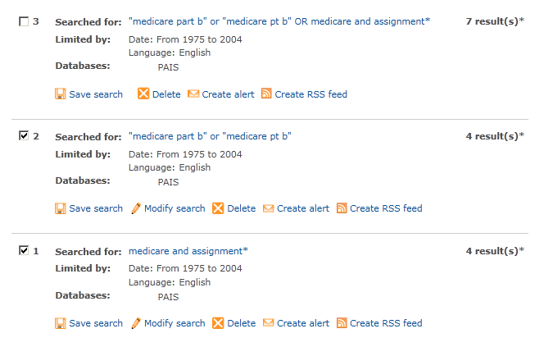
Database: PAIS <2005-2010>
Search Strategy #1: ALL
--------------------------------------------------------------------------------
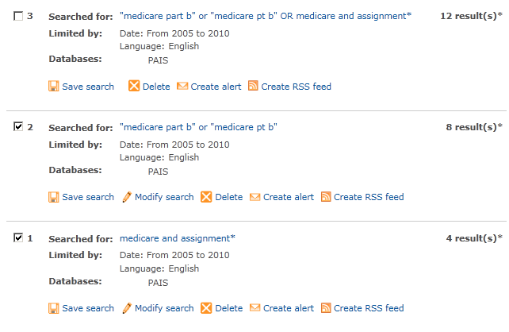
Database: Dissertation Abstracts <1975-2004>
Search Strategy #1: costs
--------------------------------------------------------------------------------
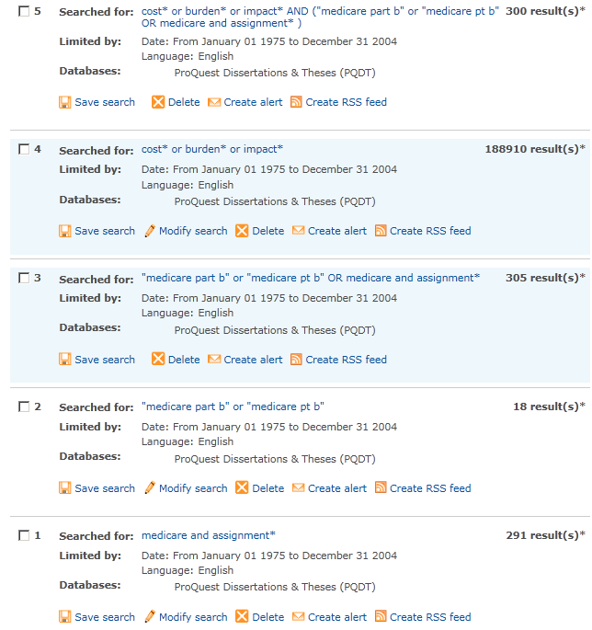

Database: Dissertation Abstracts <2005-2010>
Search Strategy #1: costs
--------------------------------------------------------------------------------
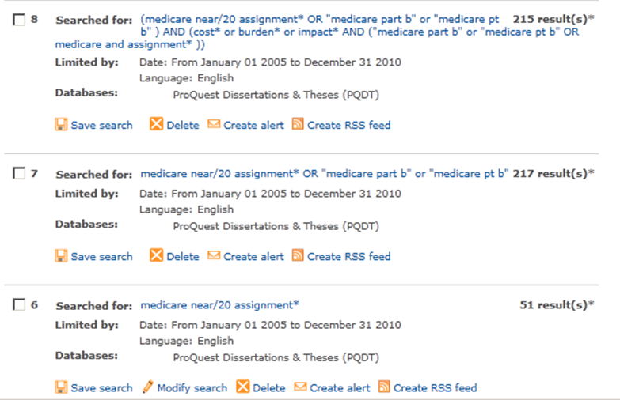
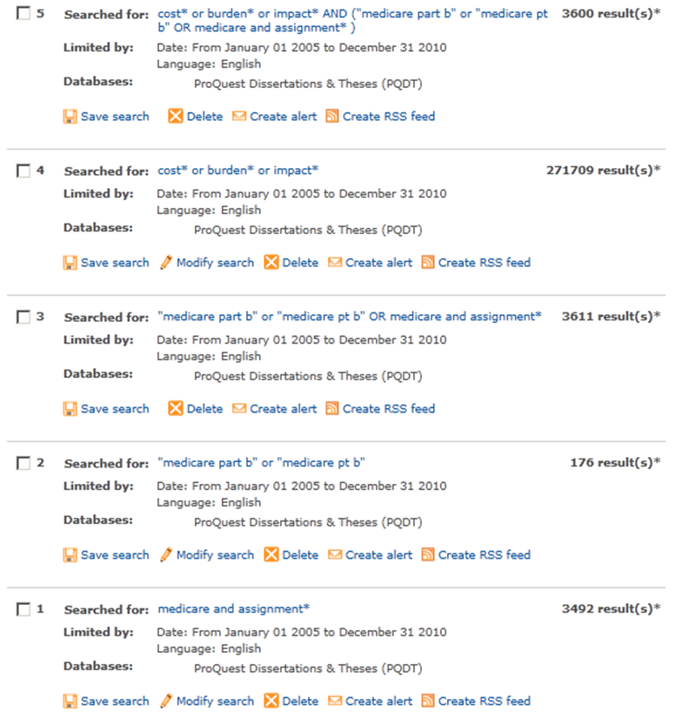
Database: Dissertation Abstracts <1975-2004>
Search Strategy #2: benefits
--------------------------------------------------------------------------------


Database: Dissertation Abstracts <2005-2010>
Search Strategy #2: benefits
--------------------------------------------------------------------------------


Database: Books in Print <1975-2004>
Search Strategy #2: benefits
--------------------------------------------------------------------------------
QUERY | # OF RESULTS
kw="medicare" and kw="assignment$" and py>=1975 and py<=2004 and la=english | 92
kw="medicare" and kw="assignment$" and kw="qualit$" and py>=1975 and py<=2004 and la=english | 22
kw="medicare" and kw="assignment$" and kw="access$" and py>=1975 and py<=2004 and la=english | 10
kw="medicare" and kw="assignment$" and kw="qualit$" and py>=1975 and py<=2004 and la=english or kw="medicare" and kw="assignment$" and kw="access$" and py>=1975 and py<=2004 and la=english | 26
kt="medicare" and kt="part b" and py>=1975 and py<=2004 and la=english or kt="medicare" and kt="pt b" and py>=1975 and py<=2004 and la=english | 8

Database: Books in Print <2005-2010>
Search Strategy #2: Benefits
--------------------------------------------------------------------------------
QUERY | # OF RESULTS
kw="medicare" and kw="assignment$" and py>=2005 and py<=2010 and la=english | 55
kw="medicare" and kw="assignment$" and kw="qualit$" and py>=2005 and py<=2010 and la=english | 13
kw="medicare" and kw="assignment$" and kw="access$" and py>=2005 and py<=2010 and la=english | 6
kw="medicare" and kw="assignment$" and kw="qualit$" and py>=2005 and py<=2010 and la=english or kw="medicare" and kw="assignment$" and kw="access$" and py>=2005 and py<=2010 and la=english | 15
kt="medicare" and kt="part b" and py>=2005 and py<=2010 and la=english or kt="medicare" and kt="pt b" and py>=2005 and py<=2010 and la=english | 25
kt="medicare" and kt="part b" and kw="qualit$" and py>=2005 and py<=2010 and la=english or kt="medicare" and kt="pt b" and kw="access$" and py>=2005 and py<=2010 and la=english | 0

Database: Health Affairs <1981-2010>
Search Strategy #1c: Medicare assignment
--------------------------------------------------------------------------------
Searching journal content for medicare assignment (all words) in full text, from Jan 1981 through Dec 2004.
Displaying results: 147
Searching journal content for medicare assignment (all words) in full text, from Jan 2005 through Dec 2010.
Displaying results: 63
Database: Health Affairs <1981-2010>
Search Strategy #1c: balance billing
--------------------------------------------------------------------------------

Searching journal content for medicare physician* balance* bill impact* polic* (all words) in full text, from Jan 1981 through Dec 2004.

Displaying results: 258

Searching journal content for medicare physician* balance* bill impact* polic* (all words) in full text, from Jan 2005 through Dec 2010.
Displaying results: 61

Appendix C. Web Sites Used in P-1 Literature Search

Health Law/Regulation Web Sites
We began searching at Web sites known to specialize in health law and regulation generally or specific topics included in this review:
- American Health Lawyers Association
http://www.healthlawyers.org/ (no documents found)
- Findlaw.com—health law
http://www.findlaw.com/01topics/19health/index.html (no documents found)
- Health Care Compliance Association
http://www.hcca-info.org/ (no documents found)
- HealthHippo
http://frwebgate.access.gpo.gov/cgi-bin/getdoc.cgi?dbname=gao&docid=f:he94171.txt
- National Health Care Anti-fraud Association (NHCAA)
http://www.nhcaa.org/ (no documents found – member-only site)

Health Industry Trade Organizations
Health Professionals Regulation
For health professionals regulation, we searched the following industry and state agency trade organization Web sites:

General
- Federation of State Medical Boards (FSMB)
http://www.fsmb.org/ (no documents found)

Physicians/Dentists
- American Medical Association (AMA)
http://www.ama-assn.org/ (no documents found)
- American College of Physicians/American Society of Internal Medicine (ACP-ASIM)
http://www.acponline.org/ (no documents found)
- American Dental Association (ADA)
http://www.ada.org/ (no documents found)

Midlevel Practitioners
- American Academy of Physician Assistants (AAPA)
http://www.aapa.org/gandp/testimony/2005fees.html
- American Optometric Association
http://www.aoanet.org/ (no documents found)
- American College of Nurse Practitioners (ACNP)
http://www.nurse.org/acnp/ (no documents found)
- American Association of Nurse Anesthetists (AANA)
http://www.aana.com/ (no documents found)
- American College of Nurse-Midwives (ACNM)
http://www.midwife.org/ (no documents found)

Mental Health
- Policy Information Exchange PIE Online
http://www.mimh.edu/mimhweb/pie/pie.asp (no documents found)
- American Psychiatric Association
http://www.psych.org/ (no documents found)
- American Psychological Association (APA)
http://www.apa.org/ (no documents found)
- American Managed Behavioral Healthcare Association (AMBHA)
http://www.ambha.org/ (no documents found)
- National Alliance for the Mentally Ill (NAMI)
http://www.nami.org/ (no documents found)

Other Allied Health
- American Nurses Association (ANA)
http://www.nursingworld.org/ (no documents found)
- American Pharmaceutical Association (APA)
http://www.aphanet.org/ (no documents found)

State Agency Trade Organizations and Research Centers
For state agency trade organizations and health policy research centers specializing in state health policy issues not accounted for above, we searched the following Web sites:

Executive branch
- National Governors Association (NGA)
http://www.nga.org/ (no documents found)
- National Association of State Budget Officers (NASBO)
http://www.nasbo.org/ (no documents found)
- Association of State and Territorial Health Officers (ASTHO)
http://www.astho.org/ (no documents found)
- National Association of Health Data Organizations (NAHDO)
http://www.nahdo.org/default.asp (no documents found)
- National Association of State Auditors, Comptrollers and Treasurers (NASACT)
http://www.nasact.org/ (no documents found)

Legislative branch
- National Conference of State Legislatures (NCSL)
http://www.ncsl.org/ (no documents found)
- Council of State Governments (CSG)
http://www.csg.org/csg/default (no documents found)
- National Academy of Public Administration (NAPA)
http://www.napawash.org/ (no documents found)

State Health Policy Research Centers
- National Academy of State Policy
http://www.nashp.org/ (no documents found)
- Pew Center on the States
http://www.stateline.org/index.do (no documents found)
- State Health Policy Web Portal Group
http://www.hpolicy.duke.edu/cyberexchange/Whatstat.htm#States
Rather than search 50 individual sites, we queried by e-mail the directors of all centers included in this group for relevant reports/studies their centers had conducted or that had been conducted by agencies in their states

Health Care/Health Policy Consulting Firms
For major health care/health policy consulting firms, we searched the following sites. Some of these specialize in human resource consulting, but were included in the event they had done industry-wide studies of regulatory costs:

- Buck Consultants Inc.
http://www.buckconsultants.com/ (no documents found)
- Deloitte & Touche
http://www.deloitte.com/vs/0%2C1616%2Csid%25253D2000%2C00.html (no documents found)
- Ernst & Young LLP
http://www.ey.com/global/content.nsf/US/Home (no documents found)
- Hewitt Associates LLC
http://was.hewitt.com/ (no documents found)
- Milliman USA Inc.
http://www.milliman.com/ (no documents found)
- PricewaterhouseCoopers LLP
http://www.pwcglobal.com/ (no documents found)
- Towers Perrin
http://www.towers.com/towers/default.asp (no documents found)
- Watson Wyatt Worldwide
http://www.watsonwyatt.com/ (no documents found)

Health Policy Research Organizations
. For major health policy research organizations, including “think tanks” and some advocacy groups, we searched the following sites:

- Abt Associates
http://www.abtassoc.com/ (no documents found)
- Alliance for Health Reform
http://www.allhealth.org/ (no documents found)
- AcademyHealth
http://www.academyhealth.org/index.html (no documents found)
- The Advisory Board Company
http://www.advisoryboardcompany.com/ (no documents found – member-only site)
- American Enterprise Institute (AEI)
http://www.aei.org/ (no documents found)
- Battelle
http://www.battelle.org/ (no documents found)
- Brookings Institution
http://www.brook.edu/ (no documents found)
- Cato Institute
http://www.cato.org/pubs/regulation/reg15n4f.html
- Center for Budget and Policy Priorities (CBPP)
http://www.cbpp.org/files/10-12-05health.pdf (new)
- Center for Health Affairs (Project HOPE)
http://www.projecthope.org/ (no documents found)
- Center for Health Care Strategies (CHCS)
http://www.chcs.org/ (no documents found)
- Center for Study of Health Systems Change (CSHSC)
http://www.hschange.com/ (no documents found)
- Employee Benefits Research Institute (EBRI)
http://www.ebri.org/ (no documents found)
- Heritage Foundation
http://www.hschange.com/ (no documents found)
- Institute of Medicine (IOM)
http://www.iom.edu/ (no documents found)
- Lewin Group
http://www.Quintiles.com/Specialty_Consulting/The_Lewin_Group/default.htm (no documents found)
- Mathematica Policy Research (MPR)
http://www.mathematica-mpr.com/HEALTH.HTM (no documents found)
- National Bureau of Economic Research (NBER)
http://www.nber.org/ (no documents found)
- National Health Policy Forum
http://www.nhpf.org/ (no documents found)
- RAND Health
http://www.rand.org/health_area/ (no documents found)
- Research Triangle Institute (RTI)
http://www.rti.org/pubs/statepaymentlimits.pdf
- Urban Institute
http://www.urban.org/ (no documents found)

Major Health Policy Foundations. For major health policy foundations, we searched the following sites:

- California Healthcare Foundation
http://www.chcf.org/ (no documents found)
- Commonwealth Fund
http://www.cmwf.org/ (no documents found)
- Robert Wood Johnson Foundation
http://www.rwjf.org/research/researchdetail.jsp?id=1420&ia=142
http://www.rwjf.org/research/researchdetail.jsp?id=1186&ia=137
- Henry J. Kaiser Family Foundation
http://www.kff.org/ (no documents found)
- United Hospital Fund
http://www.uhfnyc.org/ (no documents found)

Health professionals include physicians (defined to include doctors of medicine and doctors of osteopathy), physician assistants, nurse practitioners, clinical nurse specialists, certified registered nurse anesthetists, certified nurse midwives, clinical psychologists and clinical social workers.
Section 4507 of the Balanced Budget Act of 1997 amends section 1802 of the Social Security Act, 42 U.S.C. section 1395a (Hoff 2002).
The complete legislative history, including the interim limits, is described in Murray and Poisal (1998).
H.E. Frech, III, personal communication, February 24, 2003.

