Cost of Health Services Regulation
Working Paper Series

Professional Medical Records

Health Professionals Regulation
Working Paper No. P-3

Prepared by

Christopher J. Conover
with
Emily P. Zeitler

Center for Health Policy, Law and Management

Duke University


Under contract to the

Agency for Healthcare Research and Quality

With funding from ASPE/DALTCP

The authors thank Anne Farland, Matthew Piehl, and Catherine Wu for excellent research assistance with this paper.

Section I. Introduction

Background

We earlier focused on medical records regulation as it affects health facilities (Working Paper F-7). Here we focus on such regulation as it relates to offices of physicians, dentists and other health professionals. The rationale, statutory authority, key elements, scope, enforcement provisions and theoretical impact detailed in the facilities write-up are equally applicable here.

Research Questions

This working paper covers two major topic areas framed within two research questions, all of which are related to the impact of medical privacy rules for medical records maintained by health professionals in the U.S. Our primary goal was to identify, review, and evaluate the published literature to answer the research questions with the intent of developing an interim estimate of the costs and benefits of such privacy rules; our secondary goal was to identify areas where no evidence exists or where the evidence has important limitations and then describe the type of data that would be needed to more fully address the question. In Working Paper F-7 we address these issues as they relate to medical records maintained by health facilities.
The questions are listed below by topic area, along with a brief description of our analytical approach, including outcomes of interest.

Costs of Medical Records Regulation for Health Professionals
Question 1a. What is the amount of government regulatory costs related to medical privacy rules for health professionals? This includes federal costs to monitor and enforce rules related to medical records (including privacy protection), as well as parallel efforts at the state level.
Question 1b. What is the amount of industry compliance costs related to medical privacy rules for health professionals? This includes all administrative costs and enforcement penalties borne by medical practices subject to federal or state medical records regulations. Monetary penalties may be viewed as a transfer, but the remaining costs represent real resource losses to society.
Question 1c. What is the magnitude, if any, of efficiency losses associated with medical privacy rules? In theory, privacy restrictions can stand in the way of an efficient marketplace since limiting access to personal information may prevent exchanges that could be welfare-enhancing (Posner 1995; Epstein 1994).

Benefits of Medical Records Regulation for Health Professionals
Question 2a. What is the value of resource savings attributable to medical privacy rules? In theory, medical records requirements could contribute to efficiency insofar as a sizable fraction of medication errors are attributable to simple system errors resulting from a fragmented and uncoordinated delivery system (even within a single hospital). Indeed, a central premise of HIPAA was that the regulations would eliminate much inefficiency by administrative simplification. However, critics of HIPAA have focused on the privacy regulations, pointing out that strict adherence to these could substantially impair the timely and efficient delivery of services due to needless delays resulting from obtaining patient permission to share medical information. At least some of these concerns have been addressed in the final regulations issued in August 2002, superseding the “final” regulations originally issued in April 2001.
In addition, failure to protect privacy could distort behavior in an inefficient way if fear of job loss or social discrimination leads individuals to withhold important information from their physicians or avoid seeking care altogether. Likewise, when personal health data is disclosed and results in an individual’s losing coverage, for example, there is a cost associated with that (Schwartz 1997).

Limitations of Working Paper

Section II. Methods

Literature Search and Review

Sources

Peer-Reviewed Literature
We performed electronic subject-based searches of the literature using the following databases:
- MEDLINE® (1975-June 30, 2004) and CINAHL® (1975-June 30, 2004) which together cover all the relevant clinical literature and leading health policy journals
- Health Affairs, the leading health policy journal, whose site permits full text searching of all issues from 1981-present
- ISI Web of Knowledge (1978-June 30, 2004) which includes the Science Citation Expanded®, Social Sciences Citation Index®, and Arts & Humanities Citation Index™ covering all major social sciences journals
- Lexis-Nexis (1975-June 30, 2004) which covers all major law publications
- Public Affairs Information Service (PAIS), including PAIS International and PAIS Periodicals/Publishers (1975-June 30, 2004) which together index information on politics, public policy, social policy, and the social sciences in general. Covers journals, books, government publications, and directories.
- Dissertation Abstracts (1975-June 30, 2004)
- Books in Print (1975-June 30, 2004)

A professional librarian assisted in the development of our search strategy, customizing the searches for each research question. In cases where we already had identified a previous literature synthesis that included items known to be of relevance, we developed a list of search terms based on the subject headings from these articles and from the official indexing terms of MEDLINE and other databases being used. We performed multiple searches with combinations of these terms and evaluated the results of those searches for sensitivity and specificity with respect to each topic. We also performed searches on authors known or found to have published widely on a study topic. In addition to performing electronic database searches, we consulted experts in the field for further references. Finally, we reviewed the references cited by each article that was ultimately included in the synthesis. We did not hand search any journals. This review was limited to the English-language research literature. A complete listing of search terms and results is found in Appendix A.

“Fugitive” Literature
In some cases, relevant “fugitive” literature was cited, in which case we made every effort to track it down. We also performed systematic Web searches at the following sites:
- Health law/regulation Web sites
- Health industry trade organizations
- State agency trade organizations and research centers
- Major health care/health policy consulting firms
- Health policy research organizations
- Academic health policy centers
- Major health policy foundations

These searches varied by site. In cases where a complete publications listing was readily available, it was hand-searched. In other cases, we relied on the search function within the site itself to identify documents of potential relevance. Because of the volume of literature obtained through the peer-reviewed literature, including literature syntheses, we avoided material that simply summarized existing studies. Instead, we focused on retrieval of documents in which a new cost estimate was developed based on collection of primary data (e.g., surveys of state agencies) or secondary analysis of existing data (e.g., compilation of agency enforcement costs available from some other source). We excluded studies that did not report sufficient methodological detail to permit replication of their approach to cost estimation.

Inclusion Criteria
We developed the following inclusion criteria:
- Sample: wherever results from nationally representative samples were available, these were used in favor of case studies or more limited samples.
- Multiple Publications: whenever multiple results were reported from the same database or study, we selected those that were most recent and/or most methodologically sound.
- Outcomes: we selected only studies in which a measurable impact on costs was either directly reported or could be estimated from the reported outcomes in a reasonably straightforward fashion.
- Methods: we only selected studies in which sufficient methodological detail was reported to assess the quality of the estimate provided.

Where possible, we limited the review to studies using from 1975 through June 30, 2004 reasoning that any earlier estimates could not be credibly extrapolated to the present given the sizable changes in the health care industry during the past two decades. Other exclusions were as follows:
- Unless we had no other information for a particular category of costs or benefits, we excluded qualitative estimates of impact.
- Estimates of impacts derived from unadjusted comparisons were discarded whenever high quality multivariate results were available to control for differences between states or across time.
- Estimates that focused on measuring system-wide impact generally were selected over narrower estimates (e.g., per capita health spending vs. cost per inpatient day) on grounds that savings achieved in one sector may have induced higher spending elsewhere in the system; hence narrower comparisons might inadvertently lead to an inappropriate conclusion.

Section III. Results

Empirical Evidence

All empirical evidence we found related to the federal privacy rule rather than state privacy regulations.
- Government Regulatory Costs. Based on the final DHHS regulatory impact assessment (RIA), total federal costs over 10 years will be $2.2 billion.
- Industry Compliance Costs: Administrative Costs. The official DHHS estimate for these regulations (net of the costs accounted for later under administrative simplification) is a net present value of 10-year costs of $11.8 billion, but there are projected to be parallel 10-year benefits whose net present value totals $19 billion. These benefits reportedly are conservative insofar as they do not account at all for the potential growth in e-health/e-commerce that might result from these regulations. The reported figures are not provided in a fashion that allows for easy estimation of the portion borne by health facilities, but based on figures regarding the impact on small businesses, we can infer that a detailed breakdown of costs shows that professional costs (including physician offices, dentist offices, Doctors of Osteopathy offices and other health professionals) account for between 42.1 and 58.4 percent of this total.
- The Nolan study estimates the 5-year cost at $42.9 billion—more than six times the official figure.

Net Assessment

We generally calculate costs as we did earlier for facilities except that we calculate differences shares of these costs attributable to professional medical records regulation.
- Government Regulatory Costs. Enforcement expenditures are not directly reported, although they are included in the total, so we approximated these assuming that 5% of reported federal costs would be allocated to OCR enforcement activities and multiply this times the estimate professional share of medical records regulatory costs.
- Industry Compliance Costs: Administrative Costs. We have annuitized the multiple year Privacy Rule cost estimates using the same method used by OMB in its annual regulatory cost assessment (OMB 2002), e.g., assuming a 7 percent discount rate.
- Social Welfare Losses: Efficiency Losses from Tax Collection. To account for the efficiency losses associated with raising taxes to pay for government regulatory costs, we multiply the latter times the marginal cost of income tax collections (see Table B-1 for how these costs are calculated).
- Social Welfare Losses: Efficiency Losses from Regulatory Costs. All industry compliance costs, including additional uncompensated care induced by pools are presumed to be roughly equivalent to an excise tax, i.e., raising prices and reducing demand/output correspondingly. We therefore multiply these costs times the marginal excess burden associated with output taxes, using 21% (15%, 28%) as the expected value of MEB (see Table B-1 for details of how MEB is calculated).
- Social Welfare Benefits: We use the DHHS benefits figures as our expected value figure.

All told, medical records regulations results in expected costs of $1,024 million (731, 7,846) and expected benefits of $1,260 million (1,056, 1,464).

Net Assessment
Accordingly, we estimated the cost of the Privacy Rule on the offices of physicians, dentists, D.O.’s and other health professionals using the same approach described for the equivalent costs for facilities. This resulted in an estimated net cost of $845 million ($637, $6112) and estimated annual benefits of $1.3 billion ($1.0, $1.5).

Acronyms
JCAHO Joint Commission on Accreditation and ???
HIPAA ????
DHHS Department of Health and Human Services

Listing of Included Studies

1. "Making a Federal Case Out of Health Care." (2002).
2. Anonymous. "Confidentiality of Alcohol and Drug Abuse Patient Records--PHS. Final Rule." Federal Register 52, no. 110 (June 1987): 21796-814.
3. Barnard, J. and D. Fine. "The HIPAA Privacy Rule and Its Impact on Pediatric Research.[Comment]." 37, no. 5 (November 2003): 527.
4. Black, N. "Secondary Use of Personal Data for Health and Health Services Research: Why Identifiable Data Are Essential.".
5. Bradley-Springer, L. "Human Immunodeficiency Virus Infection in the Healthcare Worker.".
6. Collins, F. S. and M. K. Mansoura. "Symposium: Testing and Telling?: Implications for Genetic Privacy, Family Disclosure and the Law; Article: Medical Implications of the Genetic Revolution." 1 (1998): 329.
7. Cuzmanes, P. T. and C. P. Orlando. "Automation of Medical Records : the Electronic Superhighway and Its Ramifications for Health Care Providers." 6 (1997): 19.
8. Dunn, R. "Calculating Costs for Accounting of Disclosures." 74, no. 5 (May 2003): 65-66.
9. Dunn, R. T. "HIPAA Copy Charges for Medical Records." 57, no. 12 (December 2003): 36-40.
10. Eddy, A Craig. "A Critical Analysis of Health and Human Services' Proposed Health Privacy Regulations in Light of the Health Insurance Privacy and Accountability Act of 1996." (2000).
11. Fried, Ben Merlin and others. "Perspective: E-Health: Technologic Revolution Meets Regulatory Constraint." 19, no. 6 (November 2000): 124-31.
12. Furrow, B. R. "Doctors' Dirty Little Secrets: the Dark Side of Medical Privacy." 37 (1998): 283.
13. Gostin, L. O. "National Health Information Privacy: Regulations Under the Health Insurance Portability and Accountability Act." 285, no. 23 (June 2001): 3015-21.
14. Gostin, L. O. and J. Hadley. " Health Services Research: Public Benefits, Personal Privacy, and Proprietary Interests." 129, no. 10 (November 1998): 833-5.
15. Gostin, Lawrence O and and others. "Legislative Survey of State Confidentiality Laws, With Specific Emphasis on HIV and Immunization." (1997).
16. Guthrie, Jennifer. "Time Is Running Out--the Burdens and Challenges of HIPAA Compliance: a Look at Preemption Analysis, the "Minimum Necessary" Standard, and the Notice of Privacy Practices." (2003).
17. Jacobson, P. D. "Modern Studies in Privacy Law: National Health Information Privacy Regulations Under HIPAA: Medical Records and HIPPA: Is It Too Late to Protect Privacy?" 86 (2002): 1497.
18. Jurevic, A. M. "When Technology and Health Care Collide: Issues With Electronic Medical Records and Electronic Mail." 66 (1998): 809.
19. Kilbridge, P. "The Cost of HIPAA Compliance." 348, no. 15 (April 2003): 1423-4.
20. Kulynych, J. and D. Korn. "The Genetics Revolution: Conflicts, Challenges and Conundra: Use and Disclosure of Health Information in Genetic Research: Weighing the Impact of the New Federal Medical Privacy Rule." 28 (2002): 309.
21. Lawler, F. H., D. C. Scheid, and N. J. Viviani. "The Cost of Medical Dictation Transcription at an Academic Family Practice Center." Archives of Family Medicine 7, no. 3 (May 1998-June 1998): 269-72.
22. Leufkens, H. G. "Privacy Issues in Pharmacoepidemiology: the Importance of Weighing Costs and Benefits." 10, no. 7 (December 2001): 659-62.
23. NOLAN Robert E. Nolan Company, Inc. Robert E. Nolan Company, Inc., 1999.
24. O'Herrin, J. K., N. Fost, and K. A. Kudsk. "Health Insurance Portability Accountability Act (HIPAA) Regulations: Effect on Medical Record Research.[See Comment]." 239, no. 6 (June 2004): 772-6; discussion 776-8.
25. OMB U.S. Office of Management and Budget, Office of Information and Regulatory Affairs. Federal Register, 2002. 15014-45.
26. Orentlicher, D. "Webster and the Fundamental Right to Make Medical Decisions." 15 (1989): 184.
27. Pierre, M. C. "New Technology, Old Issues: the All-Digital Hospital and Medical Information Privacy." 56 (2004): 541.
28. Sanders, R. H. and K. L. Stevens. "The More Things Change, the More They Stay the Same: an Analysis of the Impact of the HIPAA Privacy Rule on Illinois Mental Health Providers." 7, no. 1 (2003): 43-68.
29. Spriggs, M. "Defending De-Identification of Research Samples on the Grounds of Public Health Benefit.[Comment]." 40, no. 5-6 (May 2004-June 2004): 327-8; author reply 328.
30. Stearns, P. V. "Access to and Cost of Reproduction of Patient Medical Records. A Comparison of State Laws." 21, no. 1 (March 2000): 79-108.
31. Terry, N. P. "An EHealth Diptych: the Impact of Privacy Regulation on Medical Error and Malpractice Litigation." 27, no. 4 (2001): 361-419.
32. Tindall, C. D. "HIPAA: Focus on HIPAA: HIPAA and Medical Records: a Primer for the Personal Injury Lawyer." 40 (2003): 32.
33. Twomey, D. P. "Privacy and Autonomy in Health Care: Employee Privacy Law and the Developmenting Law Relating to Employee Medical Information and Other Private Matters." 2 (1998): 135.
34. Wills, N. J. "A Tripartite Threat to Medical Records Privacy: Technology, HIPAA's Privacy Rule and the USA Patriot Act." 17 (2002): 271.
35. Woodard, R. L. "Is Your Medical Information Safe? a Comparison of Comprehensive and Sectoral Privacy and Security Laws." 15 (2004): 147.
36. Wymore, E. "Current Public Law & Policy Issue: It's 1998, Do You Know Where Your Medical Records Are? Medical Record Privacy After the Implementation of the Health Insurance Portability and Accountability Act of 1996." 19 (1998): 553.

Listing of Excluded Studies

Key for Reasons for Exclusion

1. Studies with no original data
2. Studies with no outcomes of interest
3. Studies performed outside U.S.
4. Studies published in abstract form only
5. Case-report only
6. Unable to obtain the article

1. Lawler, F. H. , D. C. Scheid, and N. J. Viviani. "The Cost of Medical Dictation Transcription at an Academic Family Practice Center." 7, no. 3 (May 1998-June 1998): 269-72.

Appendix A. Evidence Tables

Appendix B. Search Strategies

Database: Ovid MEDLINE(R) <1975-2010>
Search Strategy #1: costs
--------------------------------------------------------------------------------
# | Searches | Results
1 | exp medical records/ec, lj | 3475
2 | (cost$ or burden$ or impact$).mp. | 765093
3 | exp "Costs and Cost Analysis"/ | 160809
4 | 1 and (2 or 3) | 638
5 | privacy/ or access to information/ | 7253
6 | (private or privac$).ti. | 13380
7 | (2 or 3) and (5 or 6) | 2274
8 | 4 or 7 | 2850
9 | exp Health Personnel/ | 331746
10 | exp Practice Management/ | 28034
11 | 8 and (9 or 10) | 368
12 | personnel$.ti. and 8 | 2
13 | 11 or 12 | 369
14 | ..l/ 13 lg=en | 347
15 | ..l/ 14 yr=1975-2004 | 194
16 | ..l/ 14 yr=2005-2010 | 122

Database: Ovid MEDLINE(R) <1975-2010>
Search Strategy #1: benefits
--------------------------------------------------------------------------------
# | Searches | Results
1 | exp medical records/ec, lj | 3475
2 | privacy/ or access to information/ | 7253
3 | (private or privac$).ti. | 13380
4 | exp Health Personnel/ | 331746
5 | exp Practice Management/ | 28034
6 | (benefit$ or saving$).mp. | 379568
7 | 1 and 6 | 389
8 | (2 or 3) and 6 | 1219
9 | 7 or 8 | 1579
10 | 9 and (4 or 5) | 216
11 | personnel$.ti. and 9 | 1
12 | 10 or 11 | 216
13 | ..l/ 12 lg=en | 195
14 | ..l/ 13 yr=1975-2004 | 115
15 | ..l/ 13 yr=2005-2010 | 69

Database: CINAHL <1975-2010>
Search Strategy #1: Costs
--------------------------------------------------------------------------------
# | Query | Limiters/Expanders | Results
S17 | S10 and S14 | Limiters - English Language; Published Date from: 20050101-20101231  Search modes - Find all my search terms | 143
S16 | S10 and S14 | Limiters - English Language; Published Date from: 19750101-20041231  Search modes - Find all my search terms | 98
S15 | S10 and S14 | Search modes - Find all my search terms | 266
S14 | S11 or S12 or S13 | Search modes - Find all my search terms | 298822
S13 | MH "Private Practice Management" or MH "Practice Management Information Systems" | Search modes - Find all my search terms | 5361
S12 | TI personnel* | Search modes - Find all my search terms | 3587
S11 | MH "Health Personnel+" | Search modes - Find all my search terms | 292555
S10 | S4 or S9 | Search modes - Find all my search terms | 2040
S9 | (S2 or S3) and S8 | Search modes - Find all my search terms | 1949
S8 | S5 or S6 or S7 | Search modes - Find all my search terms | 27419
S7 | MH "Privacy and Confidentiality+" | Search modes - Find all my search terms | 12713
S6 | TI private or privac* | Search modes - Find all my search terms | 6430
S5 | (MH "Access to Information+") | Search modes - Find all my search terms | 11166
S4 | S1 and (S2 or S3) | Search modes - Find all my search terms | 109
S3 | (MH "Costs and Cost Analysis+") | Search modes - Find all my search terms | 53937
S2 | cost* or burden* or impact* | Search modes - Find all my search terms | 189380
S1 | (MH "Medical Records+/LJ/EC") | Search modes - Find all my search terms | 1189

Database: CINAHL <1975-2010>
Search Strategy #1: Benefits
--------------------------------------------------------------------------------
# | Query | Limiters/Expanders | Results
S16 | S12 and S13 | Limiters - English Language; Published Date from: 20050101-20101231  Search modes - Find all my search terms | 138
S15 | S12 and S13 | Limiters - English Language; Published Date from: 19750101-20041231  Search modes - Find all my search terms | 0
S14 | S12 and S13 | Search modes - Find all my search terms | 138
S13 | S5 or S6 or S7 | Search modes - Find all my search terms | 298822
S12 | S9 or S11 | Search modes - Find all my search terms | 690
S11 | S8 and S10 | Search modes - Find all my search terms | 657
S10 | S2 or S3 or S4 | Search modes - Find all my search terms | 27419
S9 | S1 and S8 | Search modes - Find all my search terms | 37
S8 | benefit* or saving* | Limiters - English Language; Published Date from: 20050101-20101231  Search modes - Find all my search terms | 58701
S7 | MH "Private Practice Management" or MH "Practice Management Information Systems" | Search modes - Find all my search terms | 5361
S6 | TI personnel* | Search modes - Find all my search terms | 3587
S5 | MH "Health Personnel+" | Search modes - Find all my search terms | 292555
S4 | MH "Privacy and Confidentiality+" | Search modes - Find all my search terms | 12713
S3 | TI private or privac* | Search modes - Find all my search terms | 6430
S2 | (MH "Access to Information+") | Search modes - Find all my search terms | 11166
S1 | (MH "Medical Records+/LJ/EC") | Search modes - Find all my search terms | 1189

Database: ISI Web of Science <1975-2004>
Search Strategy #1ALL: pmr
# 9 | 244 | #8 AND #5  Databases=SCI-EXPANDED, SSCI, A&HCI Timespan=1975-2004
# 8 | 251,916 | #7 OR #6  Databases=SCI-EXPANDED, SSCI, A&HCI Timespan=1975-2004
# 7 | 29,402 | (ts=((health or medical) and profession*)) AND Language=(English)  Databases=SCI-EXPANDED, SSCI, A&HCI Timespan=1975-2004
# 6 | 231,235 | (ts=(physician* or doctor* or psycholog* or dentist*)) AND Language=(English)  Databases=SCI-EXPANDED, SSCI, A&HCI Timespan=1975-2004
# 5 | 562 | #4 AND #3  Databases=SCI-EXPANDED, SSCI, A&HCI Timespan=1975-2004
# 4 | 830,934 | (ts=(statut* or law* or regulat*)) AND Language=(English)  Databases=SCI-EXPANDED, SSCI, A&HCI Timespan=1975-2004
# 3 | 19,100 | #2 OR #1  Databases=SCI-EXPANDED, SSCI, A&HCI Timespan=1975-2004
# 2 | 3,646 | (ts=(medical and (private or privac*))) AND Language=(English)  Databases=SCI-EXPANDED, SSCI, A&HCI Timespan=1975-2004
# 1 | 15,846 | (ts=("medical record*")) AND Language=(English)  Databases=SCI-EXPANDED, SSCI, A&HCI Timespan=1975-2004
Database: ISI Web of Science <2005-2010>
Search Strategy #1ALL: pmr
--------------------------------------------------------------------------------
# 9 | 178 | (#8 AND #5) AND Language=(English)  Databases=SCI-EXPANDED, SSCI, A&HCI Timespan=2005-2010
# 8 | 160,784 | (#7 OR #6) AND Language=(English)  Databases=SCI-EXPANDED, SSCI, A&HCI Timespan=2005-2010
# 7 | 29,189 | (ts=((health or medical) and profession*)) AND Language=(English)  Databases=SCI-EXPANDED, SSCI, A&HCI Timespan=2005-2010
# 6 | 140,426 | (ts=(physician* or doctor* or psycholog* or dentist*)) AND Language=(English)  Databases=SCI-EXPANDED, SSCI, A&HCI Timespan=2005-2010
# 5 | 503 | (#4 AND #3) AND Language=(English)  Databases=SCI-EXPANDED, SSCI, A&HCI Timespan=2005-2010
# 4 | 546,844 | (ts=(statut* or law* or regulat*)) AND Language=(English)  Databases=SCI-EXPANDED, SSCI, A&HCI Timespan=2005-2010
# 3 | 18,577 | (#2 OR #1) AND Language=(English)  Databases=SCI-EXPANDED, SSCI, A&HCI Timespan=2005-2010
# 2 | 2,811 | (ts=(medical and (private or privac*))) AND Language=(English)  Databases=SCI-EXPANDED, SSCI, A&HCI Timespan=2005-2010
# 1 | 16,043 | (ts=("medical record*")) AND Language=(English)  Databases=SCI-EXPANDED, SSCI, A&HCI Timespan=2005-2010
Database: Lexis-Nexis <1975-2004>
Search Strategy #1: records
--------------------------------------------------------------------------------
[((TITLE(medical and record*) and (statut* or law* or regulat*) and (physician* or doctor* or psycholog* or dentist* or psychiatrist* or (health and profession*) or (medical and profession*))) and Date(geq(1975) and leq(2004)))]
(81)

Database: Lexis-Nexis <2005-2010>
Search Strategy #1: records
--------------------------------------------------------------------------------
[((TITLE(medical and record*) and (statut* or law* or regulat*) and (physician* or doctor* or psycholog* or dentist* or psychiatrist* or (health and profession*) or (medical and profession*))) and Date(geq(2005) and leq(2010)))]
(18)

Total refs: 99

Database: Lexis-Nexis <1975-2004>
Search Strategy #1: privacy
--------------------------------------------------------------------------------
[(((medical and priva*) and (statut* or law* or regulat*) and (physician* or doctor* or psycholog* or dentist* or psychiatrist* or (health and profession*) or (medical and profession*))) and Date(geq(1975) and leq(2004)))]
(52)

Database: Lexis-Nexis <2005-2010>
Search Strategy #1: privacy
--------------------------------------------------------------------------------
[(((medical and priva*) and (statut* or law* or regulat*) and (physician* or doctor* or psycholog* or dentist* or psychiatrist* or (health and profession*) or (medical and profession*))) and Date(geq(2005) and leq(2010)))]
(22)

Total: 74

Database: PAIS <1975-2004>
Search Strategy #1ALL: pmr
--------------------------------------------------------------------------------
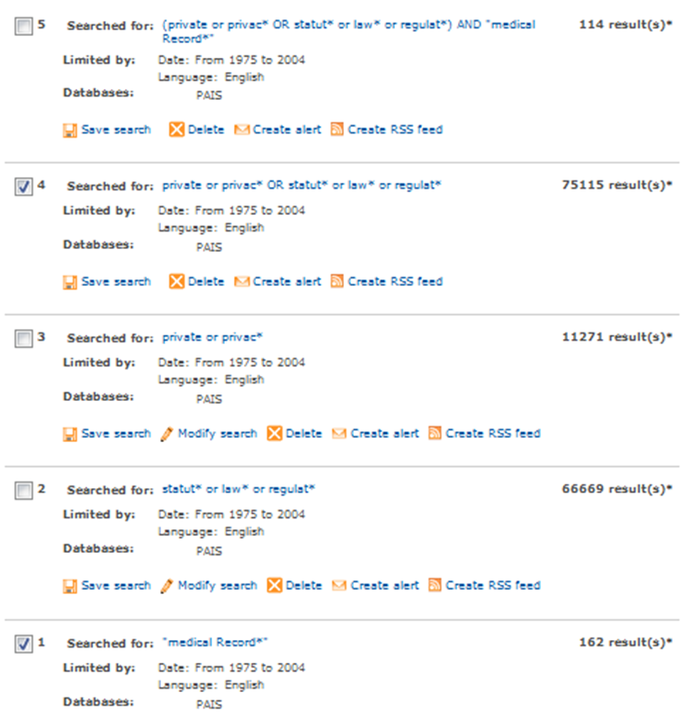
Database: PAIS <2005-2010>
Search Strategy #1ALL: pmr
--------------------------------------------------------------------------------


Database: Dissertation Abstracts <1975 to 2004>
Search Strategy #1ALL: pmr
--------------------------------------------------------------------------------



Database: Dissertation Abstracts <2005-2010>
Search Strategy #1ALL: pmr
--------------------------------------------------------------------------------
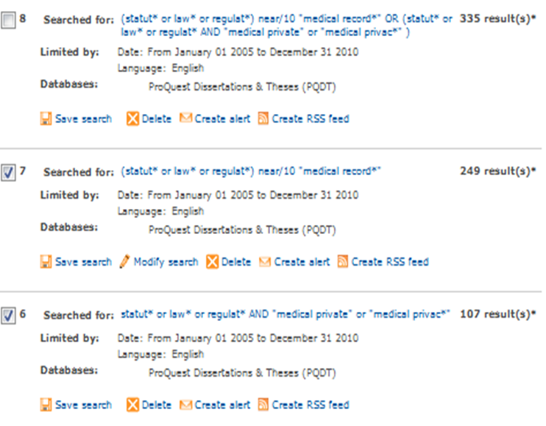
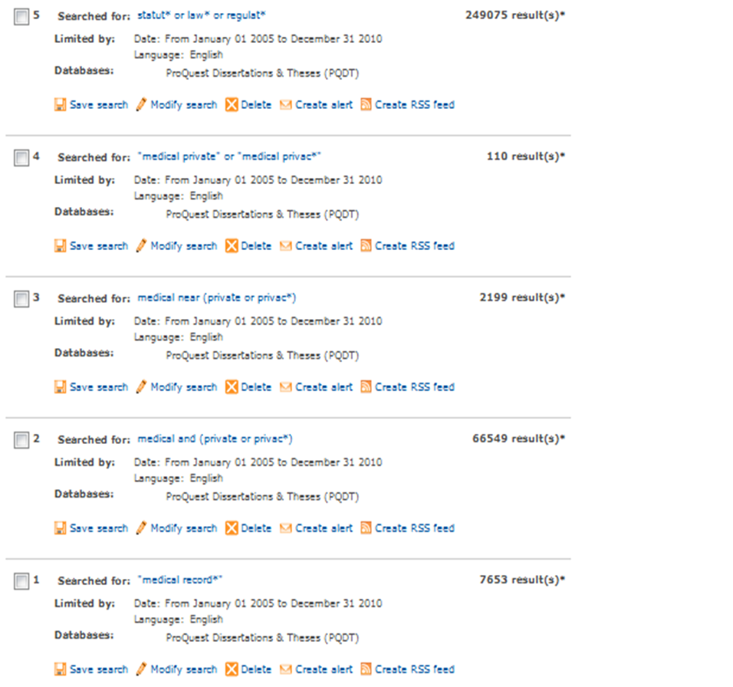
Database: Books in Print <1975-2004>
Search Strategy #1ALL: pmr
--------------------------------------------------------------------------------
QUERY | # OF RESULTS
kt="medical" and kt="record$" and kw="statut$" and py>=1975 and py<=2004 and la=english | 10
kt="medical" and kt="record$" and kt="law$" and py>=1975 and py<=2004 and la=english | 23
kt="medical" and kt="record$" and kt="regulat$" and py>=1975 and py<=2004 and la=english | 4
kt="medical" and kt="record$" and kw="statut$" and py>=1975 and py<=2004 and la=english or kt="medical" and kt="record$" and kt="law$" and py>=1975 and py<=2004 and la=english or kt="medical" and kt="record$" and kt="regulat$" and py>=1975 and py<=2004 and la=english | 27
kt="medical" and kt="priva$" and kt="statut$" and py>=1975 and py<=2004 and la=english | 5
kt="medical" and kt="priva$" and kw="law$" and py>=1975 and py<=2004 and la=english | 19
kt="medical" and kt="priva$" and kw="regulat$" and py>=1975 and py<=2004 and la=english | 8
kt="medical" and kt="priva$" and kt="statut$" and py>=1975 and py<=2004 and la=english or kt="medical" and kt="priva$" and kw="law$" and py>=1975 and py<=2004 and la=english or kt="medical" and kt="priva$" and kw="regulat$" and py>=1975 and py<=2004 and la=english | 26

Database: Books in Print <2005-2010>
Search Strategy #1ALL: pmr
--------------------------------------------------------------------------------
QUERY | # OF RESULTS
kt="medical" and kt="record$" and kw="statut$" and py>=2005 and py<=2010 and la=english | 4
kt="medical" and kt="record$" and kw="law$" and py>=2005 and py<=2010 and la=english | 28
kt="medical" and kt="record$" and kw="regulat$" and py>=2005 and py<=2010 and la=english | 12
kt="medical" and kt="record$" and kw="statut$" and py>=2005 and py<=2010 and la=english or kt="medical" and kt="record$" and kw="regulat$" and py>=2005 and py<=2010 and la=english or kt="medical" and kt="record$" and kw="law$" and py>=2005 and py<=2010 and la=english | 36
kt="medical" and kt="priva$" and kw="statut$" and py>=2005 and py<=2010 and la=english | 0
kt="medical" and kt="priva$" and kw="law$" and py>=2005 and py<=2010 and la=english | 4
kt="medical" and kt="priva$" and kw="regulat$" and py>=2005 and py<=2010 and la=english | 2
kt="medical" and kt="priva$" and kw="statut$" and py>=2005 and py<=2010 and la=english or kt="medical" and kt="priva$" and kw="law$" and py>=2005 and py<=2010 and la=english or kt="medical" and kt="priva$" and kw="regulat$" and py>=2005 and py<=2010 and la=english | 6
Database: Health Affairs <1981-2004>
Search Strategy #1ALL: medical records
--------------------------------------------------------------------------------

Searching journal content for "medical record*" law* physician* (all words) in full text, from Jan 1981 through Dec 2004.
Displaying results: 52
Database: Health Affairs <2005-2010>
Search Strategy #1ALL: medical records
--------------------------------------------------------------------------------
Searching journal content for "medical record*" law* physician* (all words) in full text, from Jan 2005 through Dec 2010.
Displaying results: 62
Database: Health Affairs <1981-2004>
Search Strategy #1ALL: medical privacy
--------------------------------------------------------------------------------

Searching journal content for medical privacy law* physician* (all words) in full text, from Jan 1981 through Dec 2004.

Displaying results: 124

Database: Health Affairs <2005-2010>

Search Strategy #1ALL: medical privacy
--------------------------------------------------------------------------------
Searching journal content for medical privacy law* physician* (all words) in full text, from Jan 2005 through Dec 2010.

Displaying results: 68

Appendix C. Web Sites Used in P-3 Literature Search

Health Law/Regulation Web Sites
We began searching at Web sites known to specialize in health law and regulation generally or specific topics included in this review:
- American Health Lawyers Association
http://www.healthlawyers.org/ (no documents found)
- Findlaw.com—health law
http://www.findlaw.com/01topics/19health/index.html (no documents found)
- Health Care Compliance Association
http://www.hcca-info.org/ (no documents found)
- HealthHippo
http://hippo.findlaw.com/hippohome.html (no documents found)
- National Health Care Anti-fraud Association (NHCAA)
http://www.nhcaa.org/ (no documents found – member-only site)

Health Industry Trade Organizations
Health Professionals Regulation
For health professionals regulation, we searched the following industry and state agency trade organization Web sites:

General
- Federation of State Medical Boards (FSMB)
http://www.fsmb.org/ (no documents found)

Physicians/Dentists
- American Medical Association (AMA)
http://www.ama-assn.org/ (no documents found—member-only site)
- American College of Physicians/American Society of Internal Medicine (ACP-ASIM)
http://www.acponline.org/journals/news/jun01/privacyrules.htm
http://www.acponline.org/journals/news/dec00/hipaasays.htm
- American Dental Association (ADA)
http://www.ada.org/ (no documents found)

Midlevel Practitioners
- American Academy of Physician Assistants (AAPA)
http://www.aapa.org/ (no documents found)
- American Optometric Association
http://www.aoanet.org/ (no documents found)
- American College of Nurse Practitioners (ACNP)
http://www.nurse.org/acnp/ (no documents found)
- American Association of Nurse Anesthetists (AANA)
http://www.aana.com/ (no documents found)
- American College of Nurse-Midwives (ACNM)
http://www.midwife.org/ (no documents found)

Mental Health
- Policy Information Exchange PIE Online
http://mimh200.mimh.edu/mimhweb/pie/database/GetArticle.asp?value=973
- American Psychiatric Association
http://www.psych.org/ (no documents found)
- American Psychological Association (APA)
http://www.apa.org/ (no documents found)
- American Managed Behavioral Healthcare Association (AMBHA)
http://www.ambha.org/ (no documents found)
- National Alliance for the Mentally Ill (NAMI)
http://www.nami.org/ (no documents found)

Other Allied Health
- American Nurses Association (ANA)
http://www.nursingworld.org/ (no documents found)
- American Pharmaceutical Association (APA)
http://www.aphanet.org/ (no documents found)

State Agency Trade Organizations and Research Centers
For state agency trade organizations and health policy research centers specializing in state health policy issues not accounted for above, we searched the following Web sites:

Executive branch
- National Governors Association (NGA)
http://www.nga.org/ (no documents found)
- National Association of State Budget Officers (NASBO)
http://www.nasbo.org/ (no documents found)
- Association of State and Territorial Health Officers (ASTHO)
http://www.astho.org/pubs/HIPAA5FINAL.pdf
- National Association of Health Data Organizations (NAHDO)
http://www.nahdo.org/default.asp (no documents found)
- National Association of State Auditors, Comptrollers and Treasurers (NASACT)
http://www.nasact.org/ (no documents found)

Legislative branch
- National Conference of State Legislatures (NCSL)
http://www.ncsl.org/ (no documents found)
- Council of State Governments (CSG)
http://www.csg.org/csg/default (no documents found)
- National Academy of Public Administration (NAPA)
http://www.napawash.org/ (no documents found)

State Health Policy Research Centers
- National Academy of State Policy
http://www.nashp.org/ (no documents found)
- Pew Center on the States
http://www.stateline.org/live/ViewPage.action?siteNodeId=136&languageId=1&contentId=15244
- State Health Policy Web Portal Group
http://www.hpolicy.duke.edu/cyberexchange/Whatstat.htm#States
Rather than search 50 individual sites, we queried by e-mail the directors of all centers included in this group for relevant reports/studies their centers had conducted or that had been conducted by agencies in their states

Health Care/Health Policy Consulting Firms
For major health care/health policy consulting firms, we searched the following sites. Some of these specialize in human resource consulting, but were included in the event they had done industry-wide studies of regulatory costs:

- Buck Consultants Inc.
http://www.buckconsultants.com/ (no documents found)
- Deloitte & Touche
http://www.deloitte.com/vs/0%2C1616%2Csid%25253D2000%2C00.html (no documents found)
- Ernst & Young LLP
http://www.ey.com/global/content.nsf/US/Home (no documents found)
- Hewitt Associates LLC
http://was.hewitt.com/ (no documents found)
- Milliman USA Inc.
http://www.milliman.com/ (no documents found)
- PricewaterhouseCoopers LLP
http://www.pwcglobal.com/ (no documents found)
- Towers Perrin
http://www.towers.com/towers/default.asp (no documents found)
- Watson Wyatt Worldwide
http://www.watsonwyatt.com/ (no documents found)

Health Policy Research Organizations
. For major health policy research organizations, including “think tanks” and some advocacy groups, we searched the following sites:

- Abt Associates
http://www.abtassoc.com/ (no documents found)
- Alliance for Health Reform
http://www.allhealth.org/ (no documents found)
- AcademyHealth
http://www.academyhealth.org/index.html (no documents found)
- The Advisory Board Company
http://www.advisoryboardcompany.com/ (no documents found – member-only site)
- American Enterprise Institute (AEI)
http://www.aei.org/ (no documents found)
- Battelle
http://www.battelle.org/ (no documents found)
- Brookings Institution
http://www.brook.edu/ (no documents found)
- Cato Institute
- http://www.cato.org/pubs/journal/cj22n1/cj22n1-3.pdf
- Center for Budget and Policy Priorities (CBPP)
http://www.cbpp.org/ (no documents found)
- Center for Health Affairs (Project HOPE)
http://www.projecthope.org/ (no documents found)
- Center for Health Care Strategies (CHCS)
http://www.chcs.org/ (no documents found)
- Center for Study of Health Systems Change (CSHSC)
http://hschange.com/CONTENT/1015/?words=medical%20records%20regulation (new)
- Employee Benefits Research Institute (EBRI)
http://www.ebri.org/ (no documents found)
- Heritage Foundation
http://www.hschange.com/ (no documents found)
- Institute of Medicine (IOM)
http://www.iom.edu/ (no documents found)
- Lewin Group
http://www.Quintiles.com/Specialty_Consulting/The_Lewin_Group/default.htm (no documents found)
- Mathematica Policy Research (MPR)
http://www.mathematica-mpr.com/HEALTH.HTM (no documents found)
- National Bureau of Economic Research (NBER)
http://www.nber.org/ (no documents found)
- National Health Policy Forum
http://www.nhpf.org/ (no documents found)
- RAND Health
http://www.rand.org/health_area/ (no documents found)
- Research Triangle Institute (RTI)
- http://www.rti.org/ (no documents found)
- Urban Institute
http://www.urban.org/ (no documents found)

Major Health Policy Foundations. For major health policy foundations, we searched the following sites:

- California Healthcare Foundation
http://www.chcf.org/ (no documents found)
- Commonwealth Fund
http://www.cmwf.org/ (no documents found)
- Robert Wood Johnson Foundation
- http://www.rwjf.org/index.jsp
- Henry J. Kaiser Family Foundation
http://www.kff.org/ (no documents found)
- United Hospital Fund
http://www.uhfnyc.org/ (no documents found)

